PARUL INSTITUTE OF AYURVED & RESEARCH
EXPERT LECTURES 2025
EXPERT LECTURE ON CEREBELLUM
he Department of Rachana Sharir, Parul Institute of Ayurved and Research, organized an insightful guest lecture on 25th January 2025 for the 1st year undergraduate students. The session was delivered by Dr. Siddharth Roy, Associate Professor, Department of Rachana Sharir, Eva College of Ayurveda, Rajkot, on the topic "Cerebellum."
Dr. Roy, with his extensive academic and teaching experience, explained the anatomical structure, functional significance, and clinical relevance of the cerebellum in a detailed and student-friendly manner. His lecture highlighted the cerebellum’s role in motor coordination, balance, and posture, correlating classical Ayurvedic understanding with modern anatomical knowledge.
The session was highly interactive and enriched with visual aids and clinical examples, which helped students grasp the complex topic with clarity. The event proved to be academically beneficial and was well appreciated by all attendees.
The lecture was coordinated successfully by the Department of Rachana Sharir under the guidance of faculty members, aiming to strengthen the foundational understanding of neuroanatomy among the students.
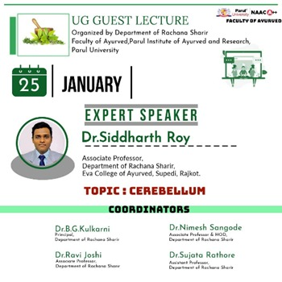 | 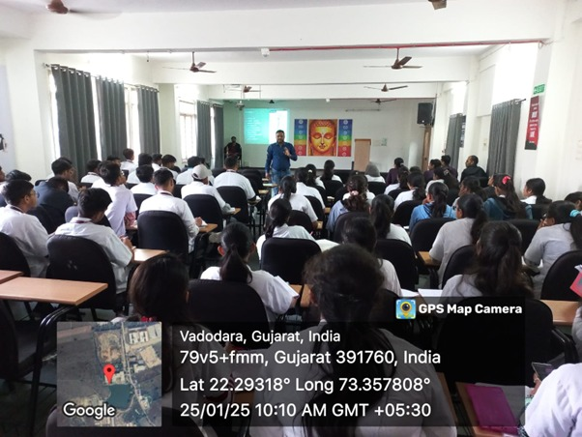

EXPERT LECTURE ON IMPORTANCE OF TANTRAYUKTI FOR UNDERSTANDING AYURVEDA
The Department of Samhita & Siddhant successfully organized a guest lecture on 15th February 2025 for the postgraduate scholars. The session was graced by Dr. Jayashree Khandge, Associate Professor and a distinguished scholar in the field of Ayurveda, who delivered an enlightening lecture on the "Importance of Tantrayukti for Understanding Ayurveda."
The program commenced with a warm welcome and brief introduction of the speaker by the Head of the Department. Dr. Khandge, known for her deep knowledge and clarity of thought, captivated the audience with her engaging and scholarly discourse.
In her lecture, Dr. Khandge emphasized the pivotal role of Tantrayukti—the interpretative tools and techniques mentioned in classical Ayurvedic texts—in accurately understanding and applying the principles of Ayurveda. She elaborated on various types of Tantrayuktis with relevant examples from the Charaka Samhita and Sushruta Samhita, demonstrating how they aid in deciphering the layered meanings embedded within the ancient texts.
She also highlighted how mastery of Tantrayukti not only refines the interpretative abilities of a student but also enhances critical thinking and systematic understanding of Ayurvedic concepts. The session was highly interactive, with PG scholars actively participating in discussions and raising thoughtful queries.
Overall, the guest lecture proved to be a highly informative and intellectually stimulating experience for all attendees.
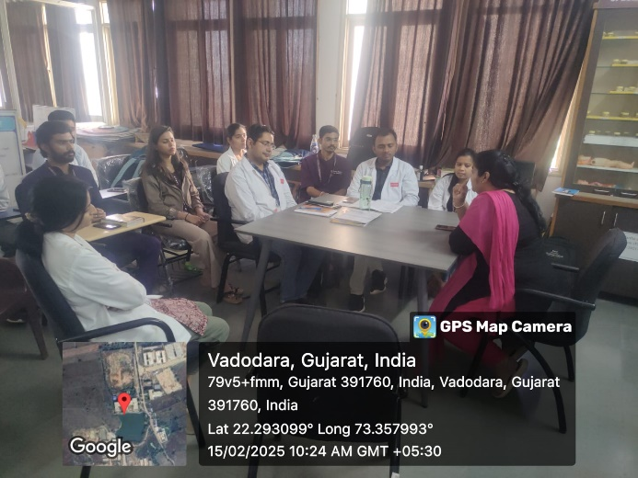 | 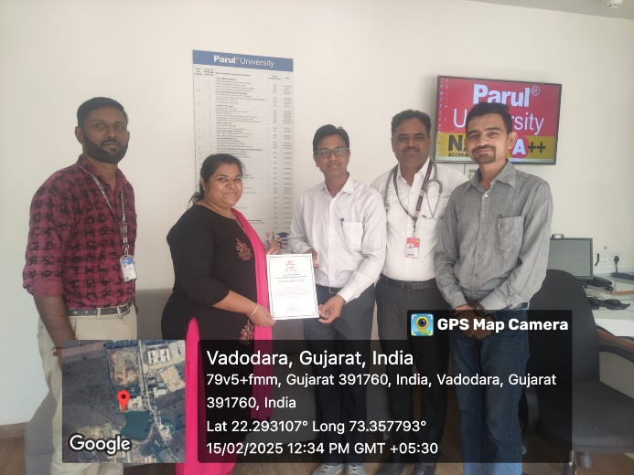

EXPERT LECTURE ON ASTRO PHYSICS BY BRAHMACHARI NIRANJANANAND SWAMIJI
The Department of Ayurveda Samhita and Siddhant successfully organised a guest lecture on April 11, 2025, featuring the esteemed Brahmachari Niranjananand Swamiji. The topic of the lecture was Astro Physics, an intriguing intersection of ancient wisdom and modern science. The session commenced with a warm welcome and floral felicitation of Swamiji, followed by an introduction highlighting his deep spiritual insight and scholarly contributions in the fields of Vedic science and cosmology.
In his lecture, Brahmachari Niranjananand Swamiji provided profound insights into the concept of the cosmos from both modern astrophysical perspectives and ancient Vedic texts. He emphasized the harmony between spiritual understanding and scientific exploration of the universe. Drawing connections between Ayurveda, cosmology, and consciousness, Swamiji captivated the audience with his clear articulation and deep knowledge. He also touched upon the significance of celestial bodies, their influence on human physiology and psychology, and how ancient seers perceived cosmic patterns through meditative and intuitive means. The lecture inspired the audience to explore the deeper dimensions of both science and spirituality. The session was attended by 100 students who actively participated and interacted with Swamiji during the Q&A segment, reflecting a keen interest in integrating ancient knowledge with modern scientific thought.
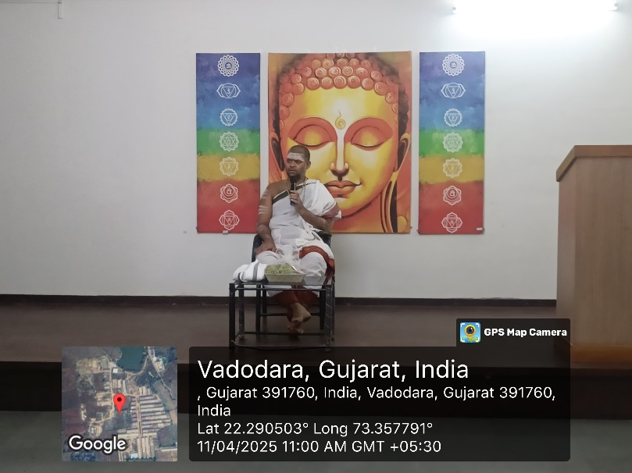 | 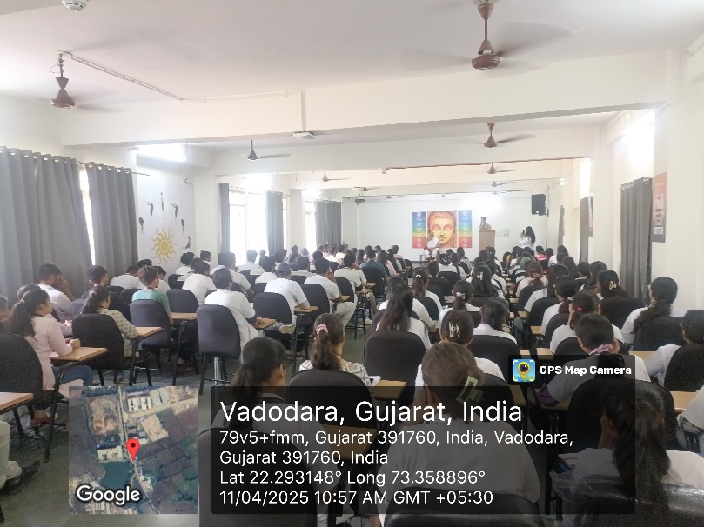

EXPERT LECTURE ON HISTOLOGY
The Department of Rachana Sharir, Parul Institute of Ayurved and Research, organized a guest lecture on Histology on 26th April 2025. The session was conducted by Dr. Parvathy, a distinguished expert in the field, who shared her in-depth knowledge and insights on microscopic anatomy relevant to Ayurvedic understanding.
The lecture covered various topics, including the basic tissue types, correlation of histological structures with Ayurvedic concepts, and the importance of histological study in clinical and academic practice. The session was attended by undergraduate students and faculty members, who actively engaged in the discussion and appreciated the practical relevance of the topic.
The lecture concluded with an interactive Q&A session, enhancing conceptual clarity among the participants. The department expressed gratitude to Dr. Parvathy for her valuable contribution to academic enrichment.
Outcome:
- Enhanced understanding of histological structures among students
- Integration of modern and Ayurvedic perspectives in anatomical studies
- Motivation for further exploration of Rachana Sharir at the microscopic level
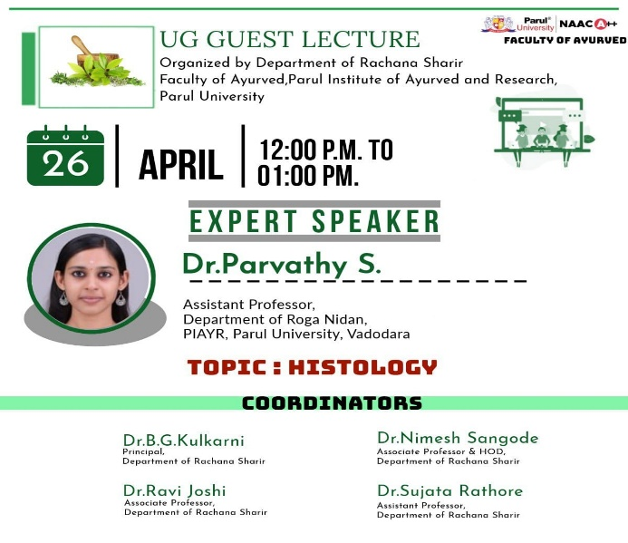 | 